21.66: a)
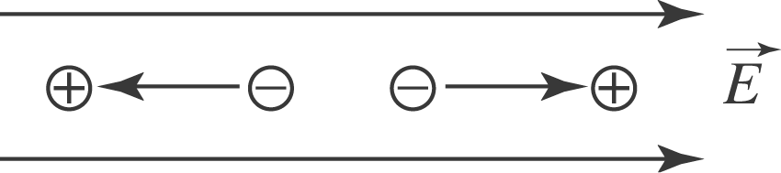
The torque is zero when 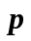 is aligned either in the same direction as 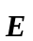 or in the opposite directions
b) The stable orientation is when is aligned in the same direction as

